TRANSPORT
Our heavy-duty trucks are specifically adapted to the bad road conditions. Our driver’s team is expert in the field. They can handle our client’s cargo with absolute care and safety. We are known for the capacity to reach remote and challenging destinations.

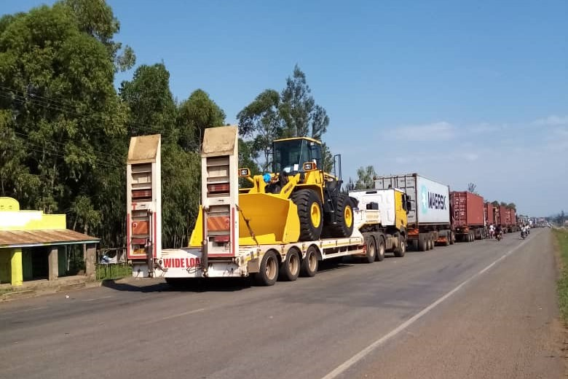

SPECIAL TRANSPORT
For extra size or dangerous goods, we offer low beds, flatbeds, refer dry cold and frozen containers, and fuel tanks. We are specialized in managing them even in difficult situations.
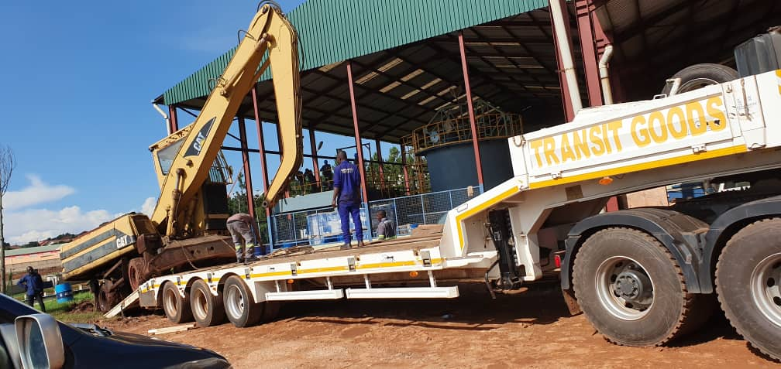

HANDLING
With a specific equipment for handling, such as elevator, cranes and platforms, we are able to handle big and heavy items that could not be managed by hand

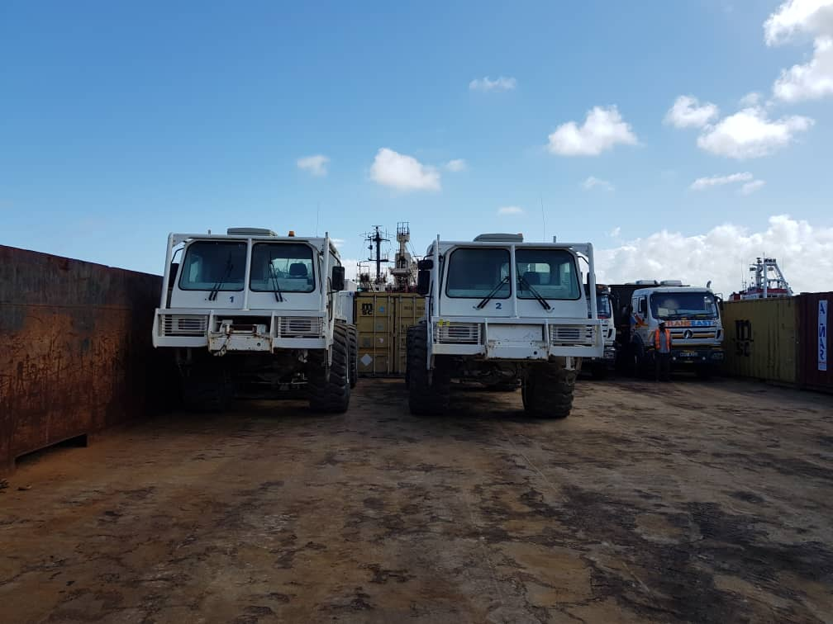

WORKSHOP
We fix earth movers, Generator vehicle, and we can provide the repair, maintenance panel beating and spraying service to our clients in our fully equipped workshop.
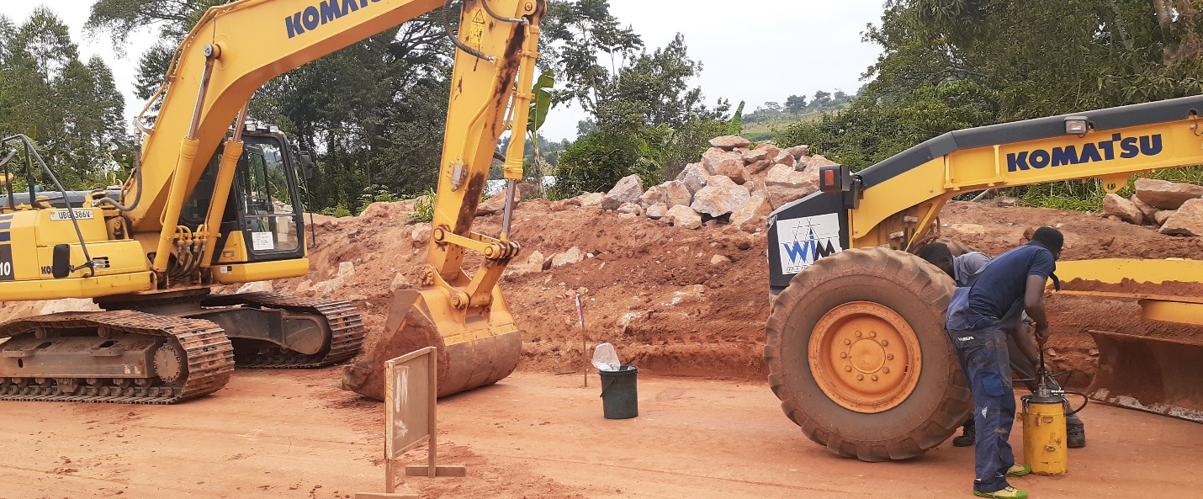
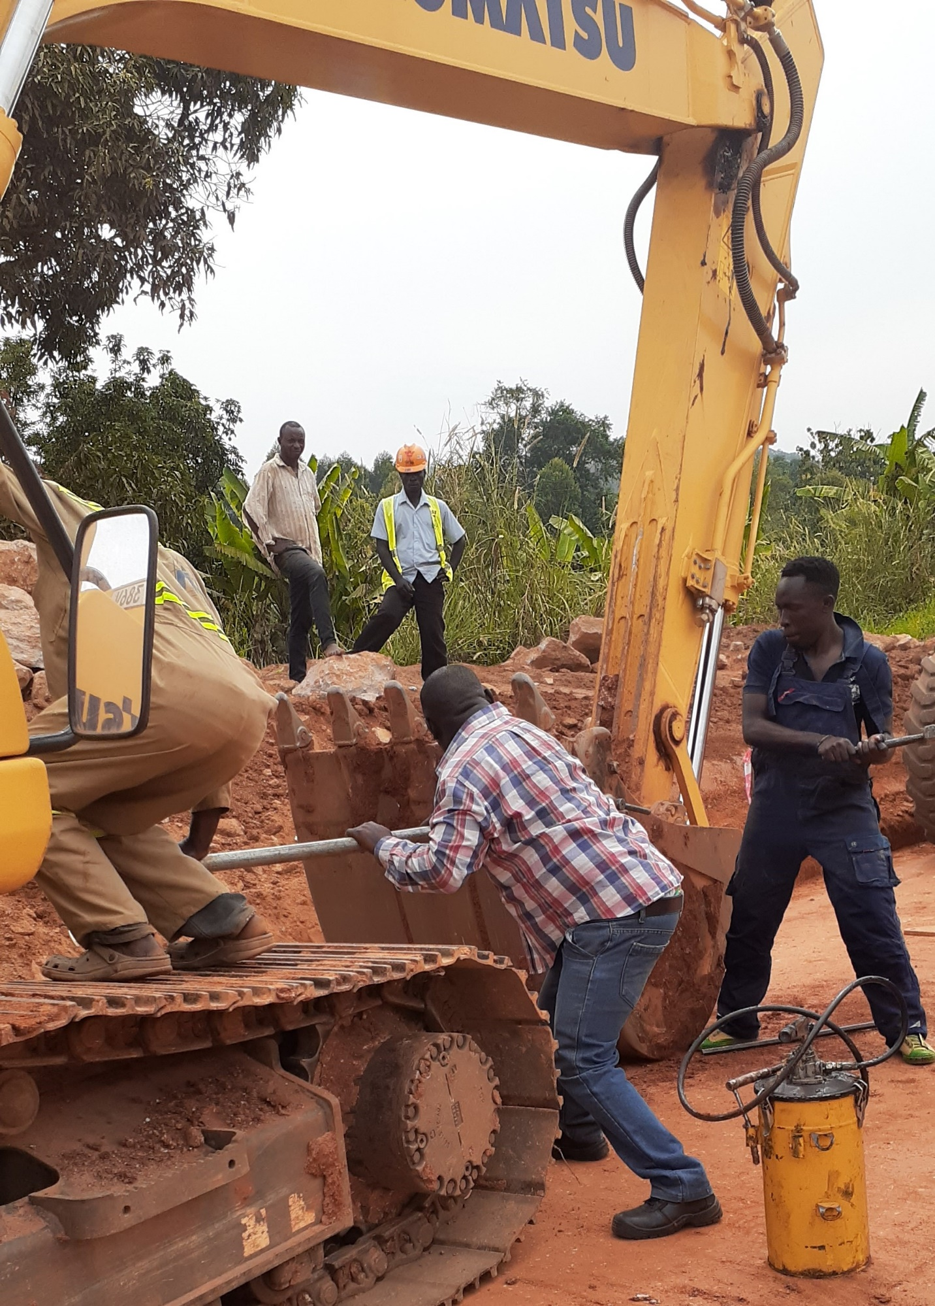
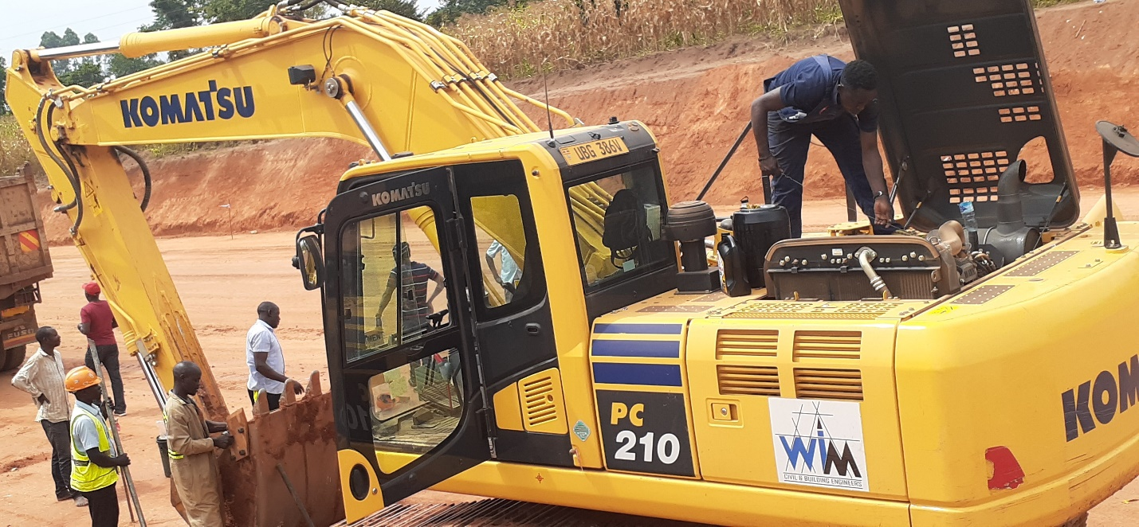
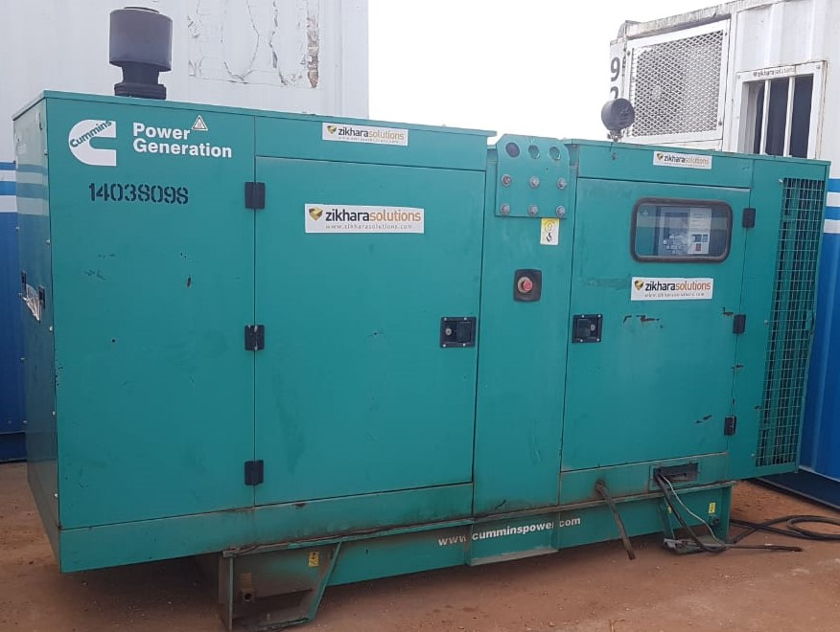

4×4 hiring

We know that you may need to hire very adapted vehicles for the field. Our 4×4 are well equipped, and can be hired with or without drivers.

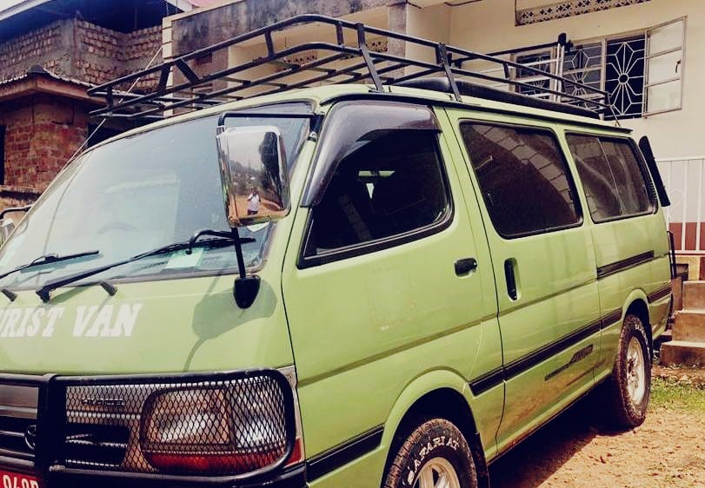
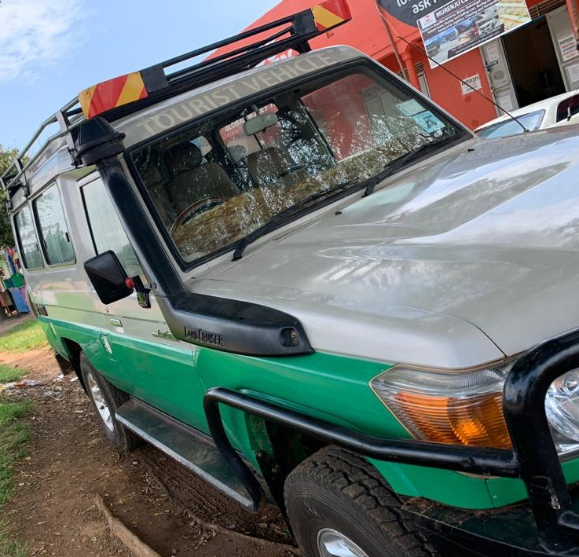

Logistics

We know that you may need a wide range of logistics services, from clearing and forwarding, office supplies, renting containers or renting generators to reinforcing vehicles or building generator shades. Tell us about it and we will see how we can help you.

Rescue

The bad conditions of the roads cause many accidents. We can rescue your truck in the city center and around the country with our recovery trucks and cranes.

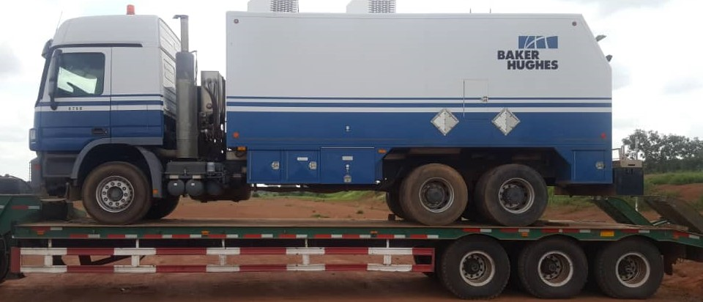
Heating Ventilation and Air Conditioning.
We can provide services to our clients install, Maintain and repair heating units and split air conditioner units.
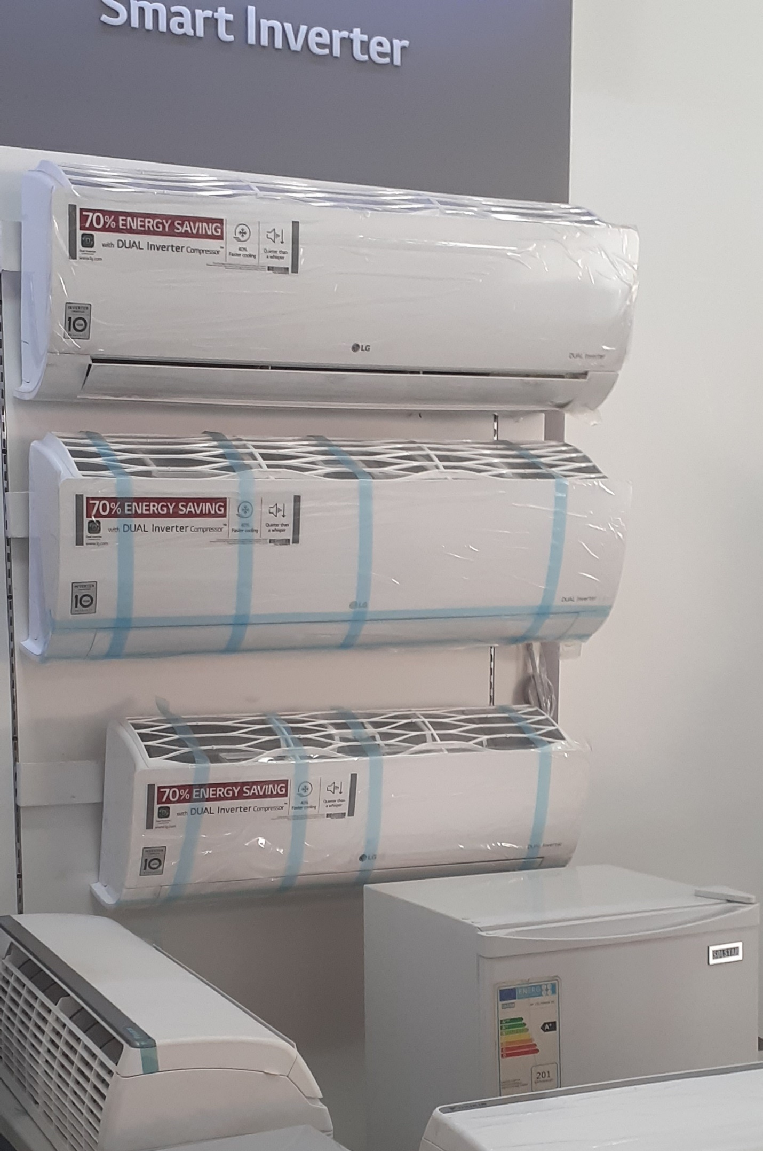
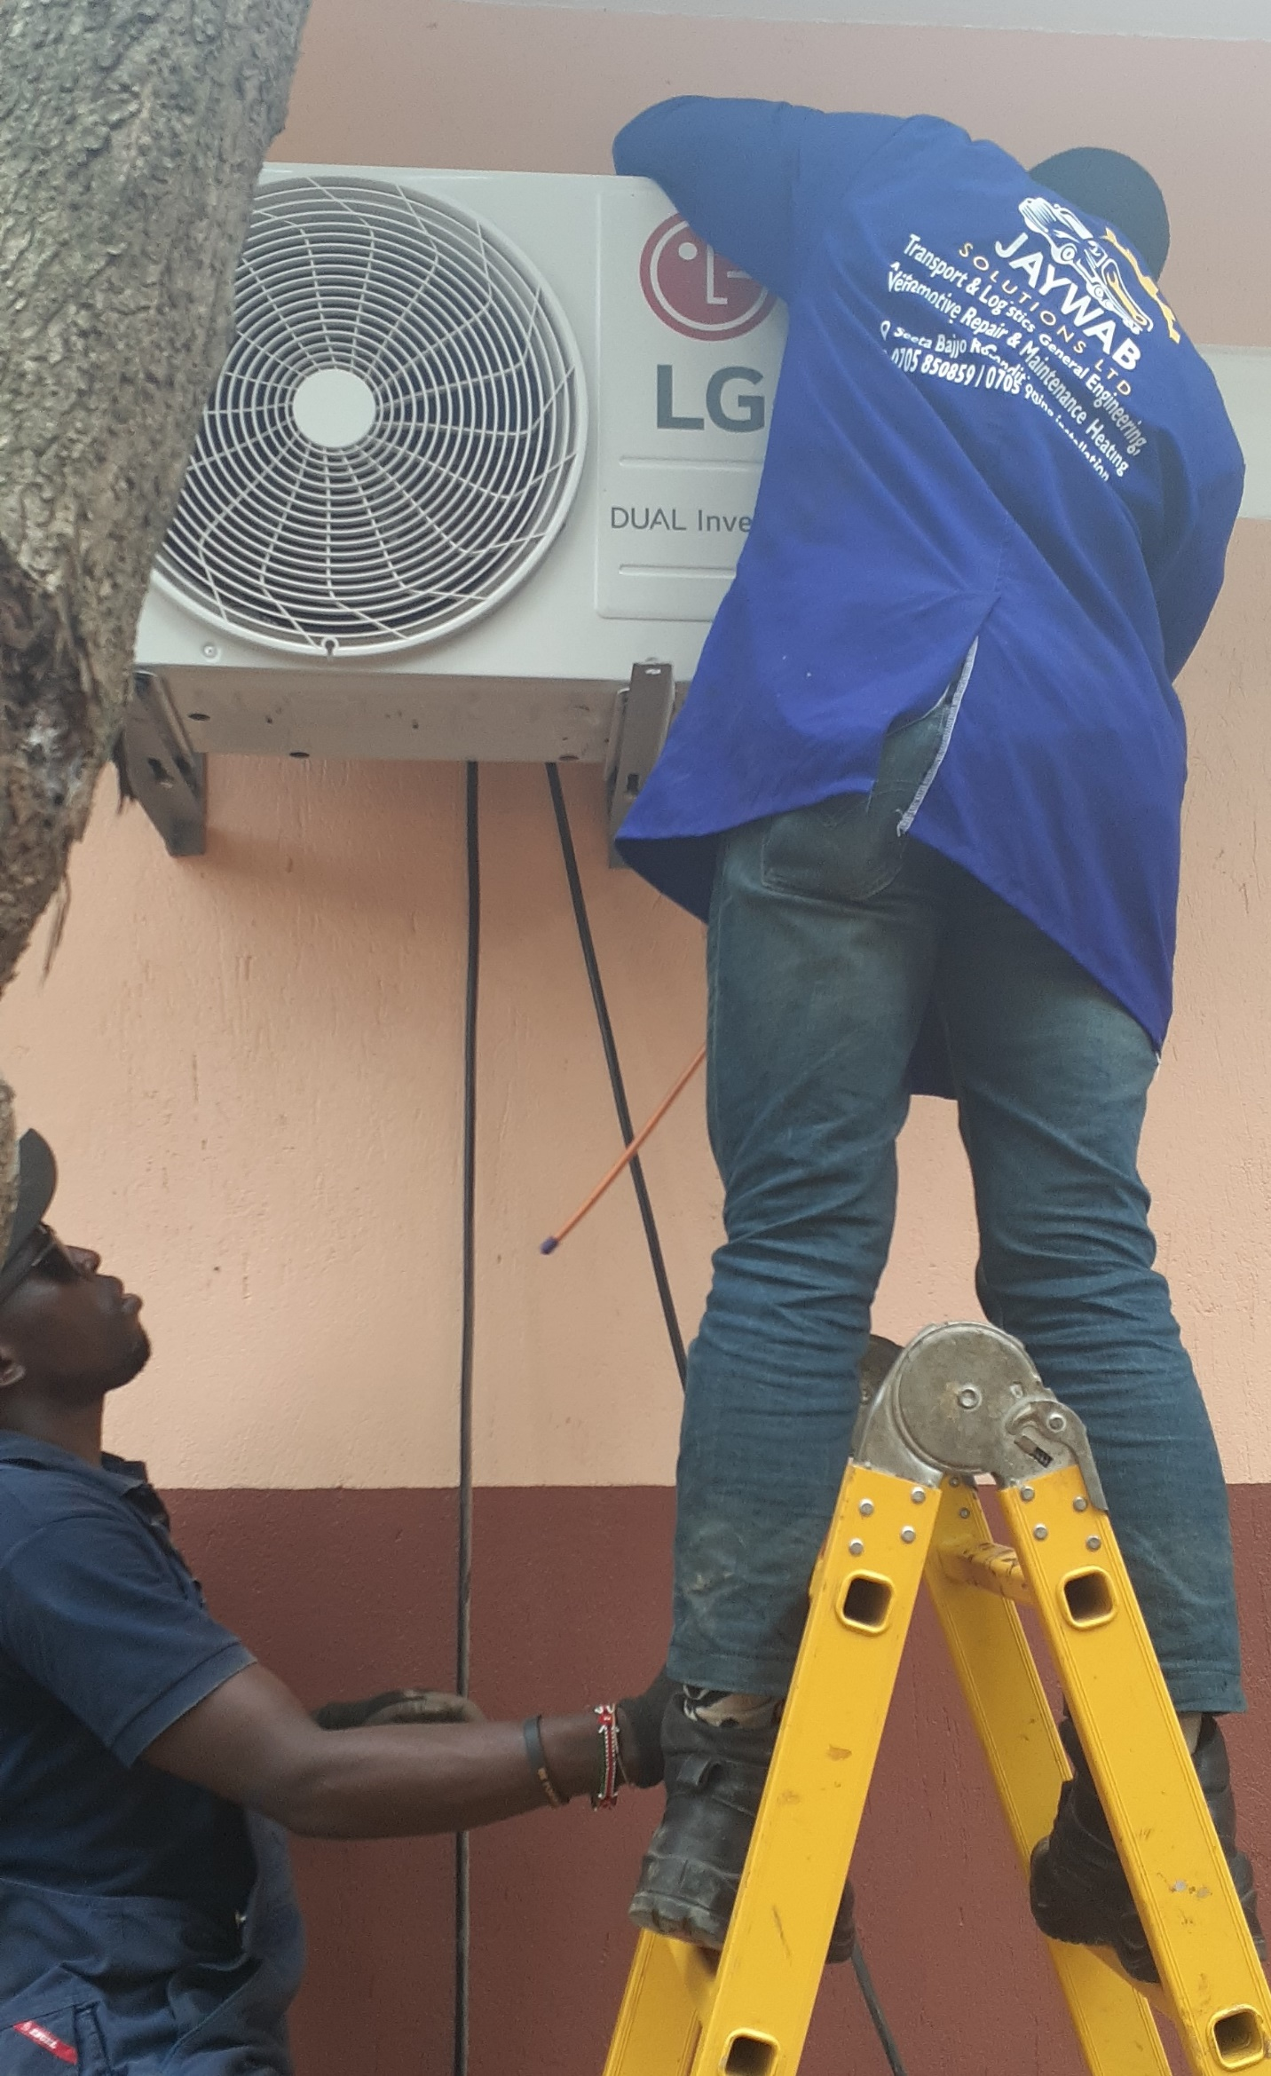
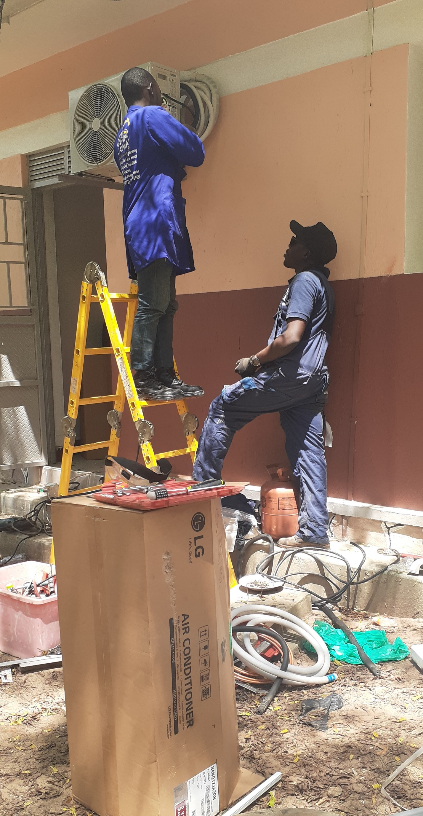
General Engineering
We know you may need engineering services from steel Welding & Fabrication, Fitting and machining Tell us about it and we see how we can help you.

